**REACT 05**

**AIM:** My Academy team at Cognizant want to create a dashboard containing the details of ongoing and completed cohorts. A react application is created which displays the detail of the cohorts using react component. You are assigned the task of styling these react components.

**CohortDashboard.js:**

import React from 'react';

import styles from './CohortDetails.module.css';

const cohortData = [

  {

    id: 101,

    title: 'Full Stack Dev - React',

    mentor: 'Ananya Gupta',

    status: 'ongoing'

  },

  {

    id: 102,

    title: 'DevOps Accelerator',

    mentor: 'Jaydeep R.',

    status: 'completed'

  },

  {

    id: 103,

    title: 'Cloud Native Apps',

    mentor: 'Samar Sinha',

    status: 'ongoing'

  },

  {

    id: 104,

    title: 'Java Spring Track',

    mentor: 'Neha Patil',

    status: 'completed'

  }

];

const CohortDashboard = () => {

  return (

    <section style={{ padding: '20px', fontFamily: 'Arial, sans-serif' }}>

      <h2 style={{ textAlign: 'center', marginBottom: '30px', color: '#2c3e50' }}>

        🎓 Cognizant Cohort Overview

      </h2>

      <div style={{ display: 'flex', flexWrap: 'wrap', gap: '15px', justifyContent: 'center' }}>

        {cohortData.map((item) => {

          const titleColor = item.status === 'ongoing' ? 'green' : 'blue';

          return (

            <div key={item.id} className={styles.box}>

              <h3 style={{ color: titleColor, marginBottom: '10px' }}>{item.title}</h3>

              <dl>

                <dt>Mentor</dt>

                <dd>{item.mentor}</dd>

                <dt>Status</dt>

                <dd>{item.status}</dd>

              </dl>

            </div>

          );

        })}

      </div>

    </section>

  );

};

export default CohortDashboard;

**CohortDetails.module.css:**

.box {

  width: 300px;

  display: inline-block;

  margin: 10px;

  padding: 10px 20px;

  border: 1px solid #000;

  border-radius: 10px;

  background-color: #90b0df;

  transition: box-shadow 0.3s ease;

}

.box:hover {

  box-shadow: 0 4px 16px rgba(0, 0, 0, 0.15);

}

dt {

  font-weight: 500;

  margin-top: 8px;

}

dd {

  margin: 0 0 8px 0;

  color: #333;

}

.dashboardBackground {

  background-color: #f780c5;

  min-height: 100vh;

  padding-top: 20px;

}

**APP.js:**

import React from 'react';

import CohortDashboard from './components/CohortDashboard';

function App() {

  return (

    <div>

      <CohortDashboard />

    </div>

  );

}

export default App;

**OUTPUT 01:**

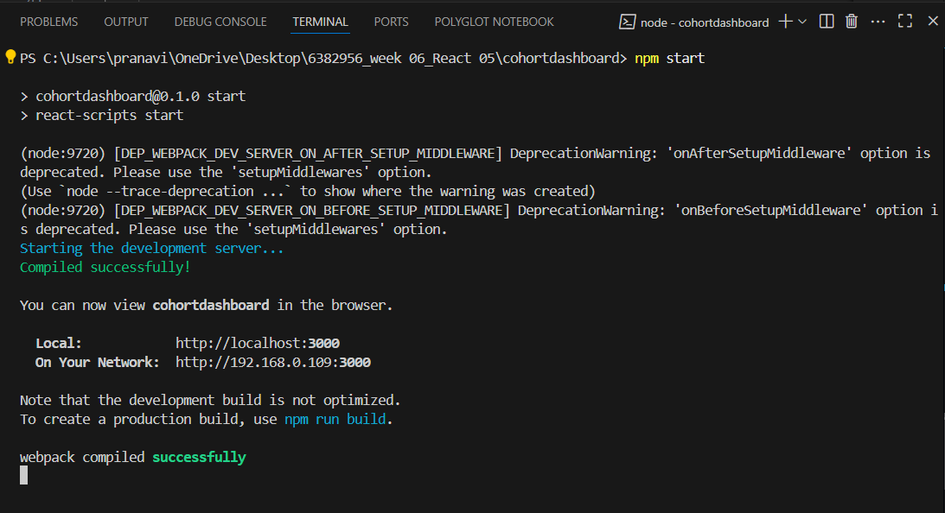

**OUTPUT 02:**